Console App Demo - Read Me

Step 1 :

This solution is build using .NET Core 1.x. Hence make sure the laptop has 1.x Installed before running the project.

Step 2: After opening the **RecordInfo** solution file, please build in below order

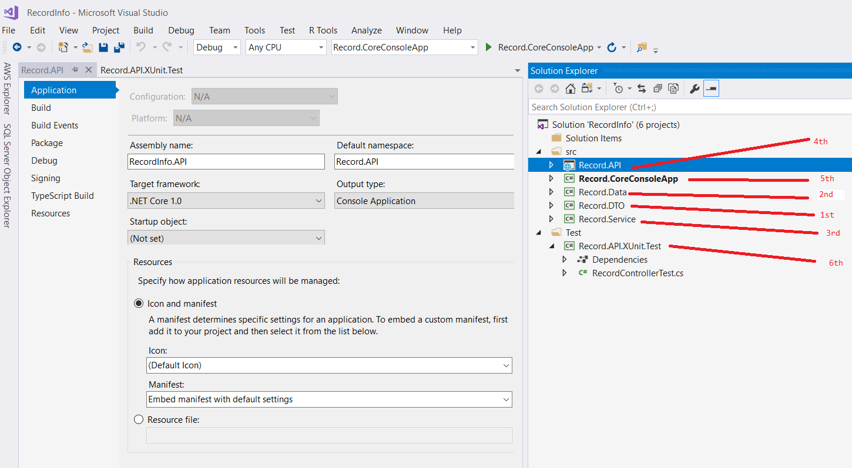

Step 3: As per the assignment, if you want to see the console application output you have to mark “Record.API.XUnit.Test” project as startup project.

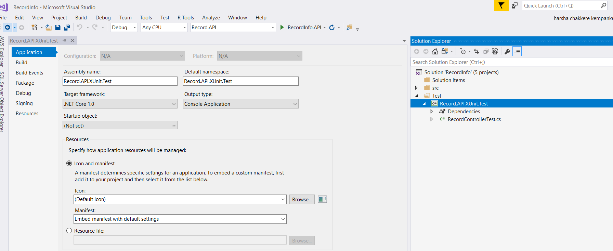

Step 4 : you can select the Unit Test case and use Debug Test or Run Test

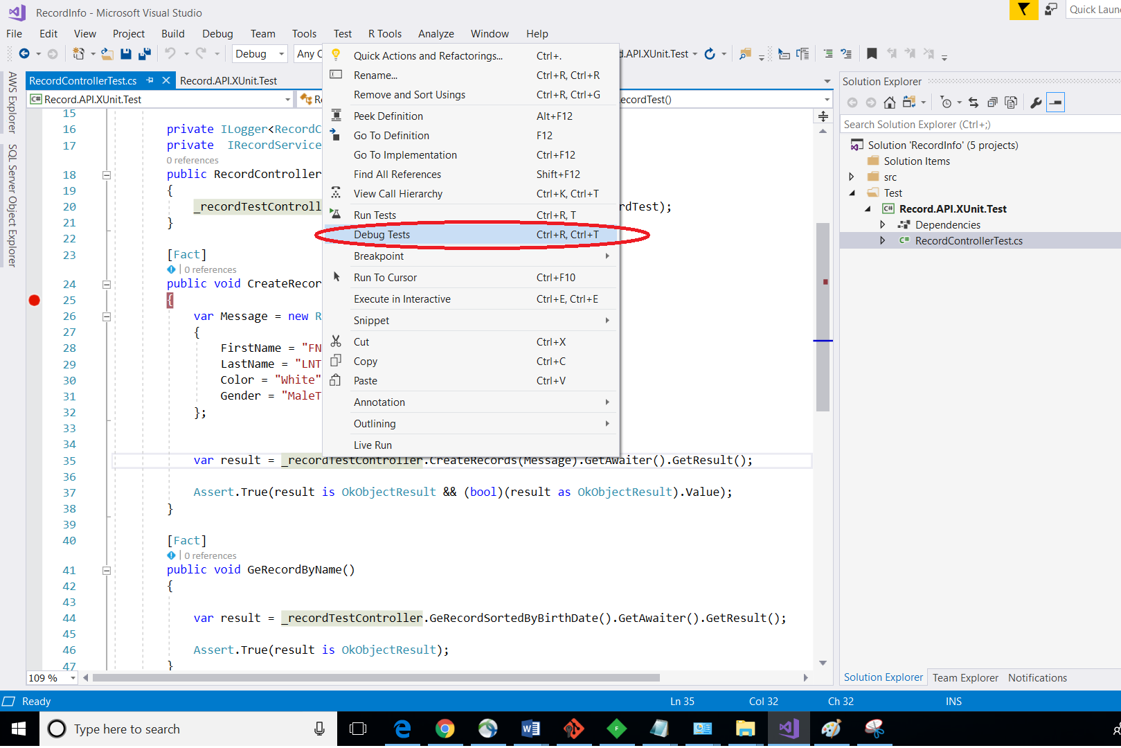

Step 5 : below is the snap shot of two unit test results

Option 1 : single unit test

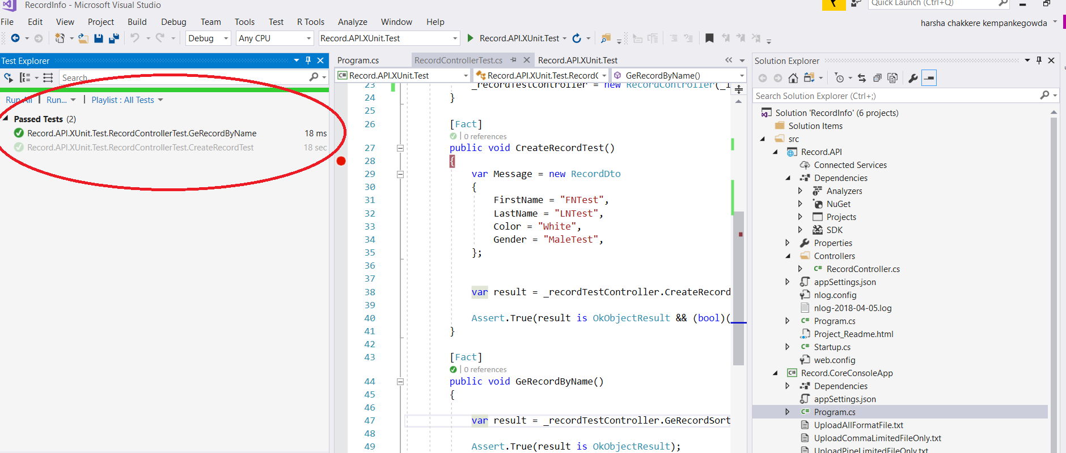

Option 1 : Full unit test

